Lab Experiments: 6-10;

6.Designing two different networks with Static Routing techniques using Packet Tracer.

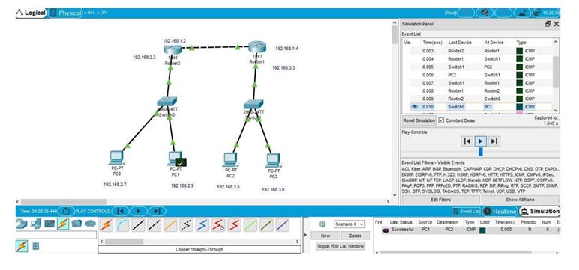

7. Designing two different networks with Dynamic Routing techniques (RIP & OSPF) using Packet Tracer.

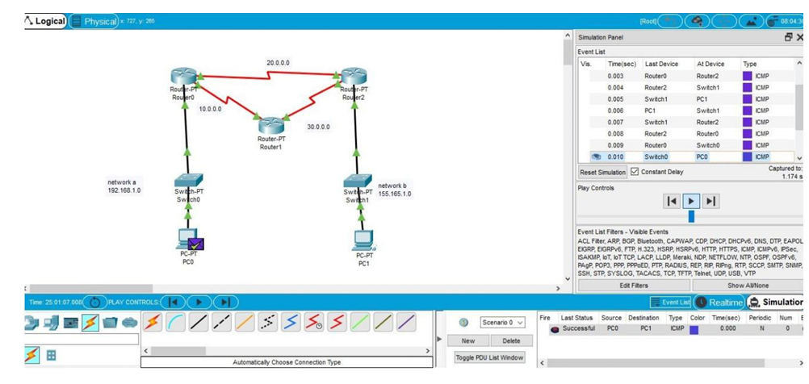

8. Subnetting – Class C Addressing using Packet Tracer.

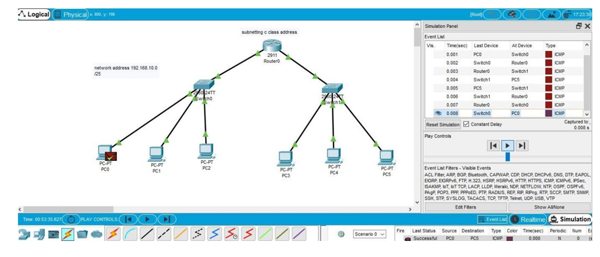

9.Functionalities and Exploration of TCP using Packet Tracer.

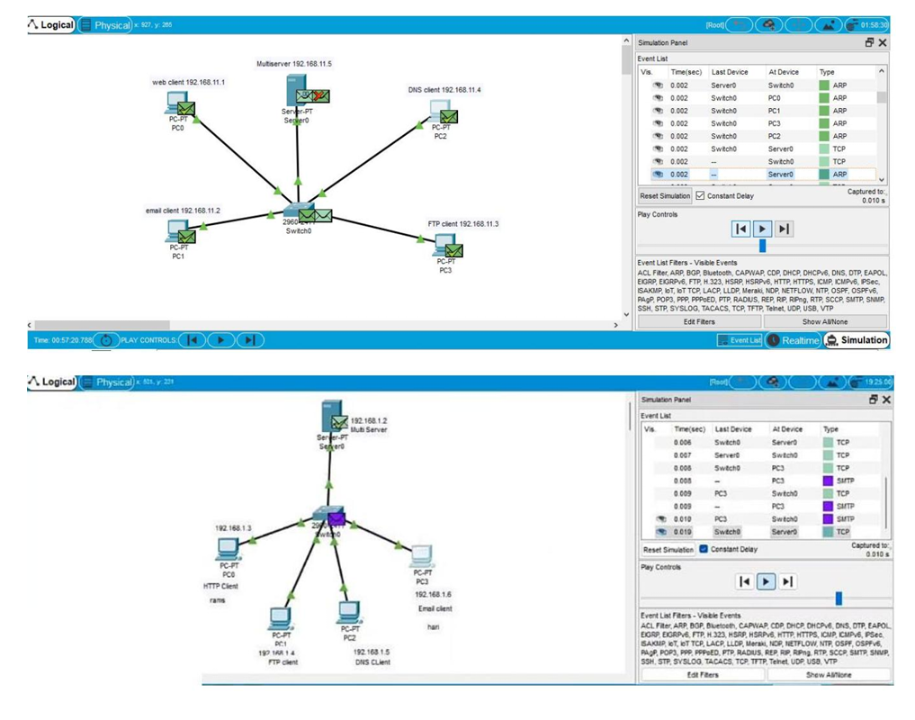

10. Design the Functionalities and Exploration of UDP using Packet Tracer.

